Problem 04.

The transition dipole moment of Oxazine 1 and Chlorophyll a :
computational approach.

In this exercise, you will use iQmol/Q-Chem suite to calculate the transition energies and transition dipole moment (TDM) of an Oxazine 1 (Oxazine 725) molecule and Chlorophyll a. Oxazine was chosen as it is the same molecule for which you measured transition energy and dipole moment experimentally. This molecule contains general motifs of organic light-absorbing molecules such as chlorophylls, i.e., ring-like π-orbitals, and thus is very efficient in visible light absorption.
Here is the structure of Oxazine 1:

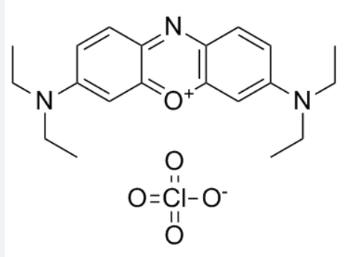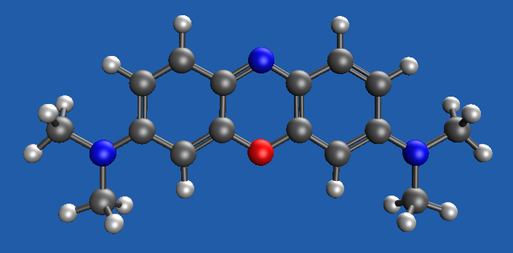

Figure 1. Left: Oxazine 1 structure. Right: constructed in iQmol with hydrogens added automatically. In iQmol, the terminal ethanol groups were replaced with methanol. Note that this is an ion with a +1 charge.

In the second part of the assignment, you will calculate the transition energy and strength for Chlorophyll a.
The chlorophyll and chlorophyll-like molecules are major components of the photosynthetic apparatus that are capable of absorbing sunlight, temporarily storing light energy in their electronically excited states, transferring this energy from molecule to molecule, and, finally, initiating charge transfer and electron transfer along the electron transfer chain. The high efficiency (close to 100%) of photosynthetic machinery relies on absorptive and emissive properties of Chl a, in particular, its transition energies to excited states and respective TDMs.

We will use the structure of the Chl a straight from the x-ray structure of photosystem I of cyanobacteria, Brookhaven Protein Database, file 5oy0.pdb. You can download the structure into iQmol from Chla-1012-PSI_cut_LS.xyz file provided on Brightspace. To facilitate calculations, the long sidechains have been removed from Chl structure since they are flexible and do not have a definite configuration. Their role in light absorption is insignificant, they play primarily structural function within a protein.

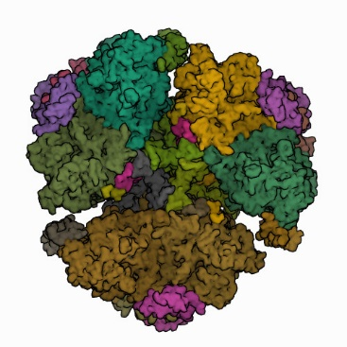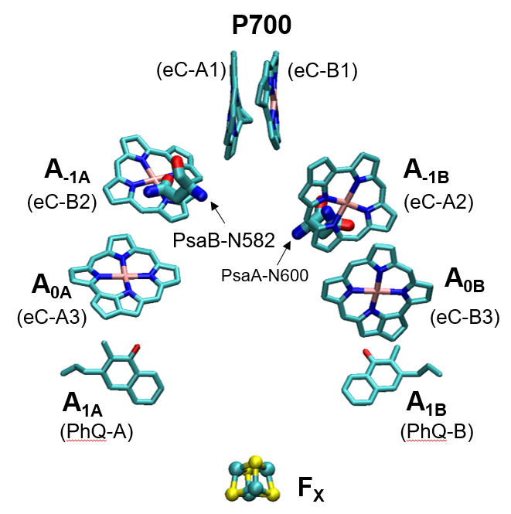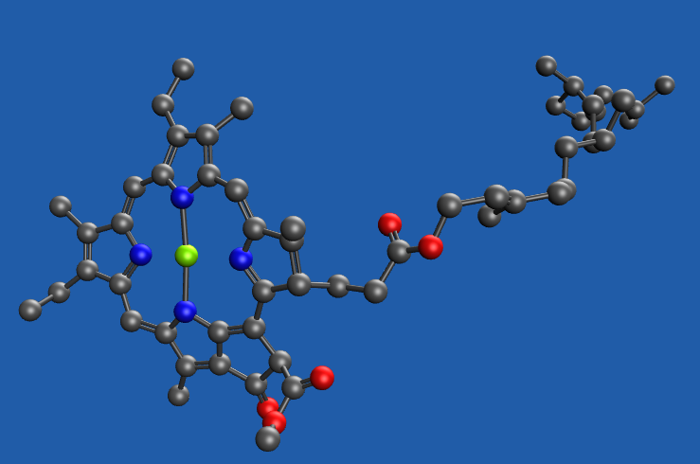

Figure 2. Left: trimeric PS I photosynthetic pigment-protein complex contains 96x3 Chl a pigments. Center: the reaction center of PS I that is involved in charge separation and electron transfer. Right: The structure of Chl a 1012, denoted as A_{-1A} (accessory pigment) in the center diagram. The flexible side chains in file Chla-1012-PSI_cut_LS.xyz are removed.

It is highly recommended that you first run the calculations described below for a very simple molecule, such as methane (CH₄). To build it, click in the blue window to put one carbon atom in the mouse position, then click two buttons  to add hydrogens and roughly minimize the geometry of a molecule. Since it is a simple molecule, you can run jobs on the default Q-Chem server (time limit 10 minutes, 1 CPU)

Your task:
- INSTALL iQmol
as described in the iqmol_instructions.docx file

- BUILD the Oxazine 1 molecule or load Chl a molecule from xyz file.
Use iQmol tools to build the molecule, but replace the 4 ethanol side groups with methanol groups as shown in Figure 1. Ethanol sidechains can flip-flop around as their structure is not rigid, and that causes the geometry optimization program to run indefinitely. The absorptive properties of this molecule are primarily defined by the π-orbitals that run around the rings. Be sure to correctly set the double bonds. Do not forget to add hydrogens to the structure. Hydrogens are often omitted from the structure for brevity. iQmol can add these automatically using the  button. Also, run a rough structure optimizer by pressing the  button.
Chl a structure is given in an XYZ file (download from Brightspace), it is extracted from Photosystem I X-ray structure.

- GEOMETRY OPTIMIZATION.
Run Q-Chem geometry optimization of the molecule on Scholar.

In the Q-Chem Calculation menu, define the task:
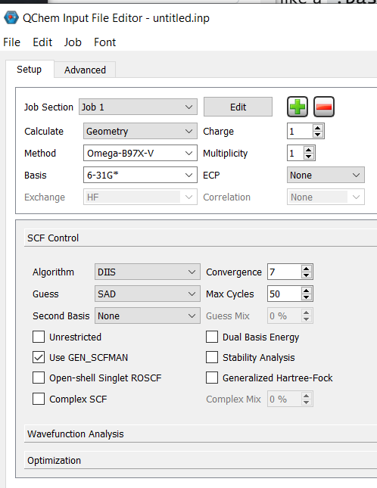
Calculate: “Geometry”
Method: Omega-B97X-V
Basis: 6-31G*

Since Oxazine is a charged molecule, set Charge=1 for it. Set Charge=0 for a neutral molecule such as Chl a. Once the Charge is correct, set Multiplicity=1.

To speed up calculations, set Convergence to 7 in the SCF Control tab (default is 8). Leave the rest of the parameters to their default values.
Submit the job to the server (scholar), set a time limit to 4 hours, and pick the job name (like “oxazine”).
Computation may take about 5 minutes or more for Oxazine, depending on the load on the server (on Scholar with 20 CPUs working in parallel).

- ANALYZE THE RESULTS
Once calculations are finished, transfer the files from Scholar back to your PC directory and open that directory in iQmol for viewing the results.

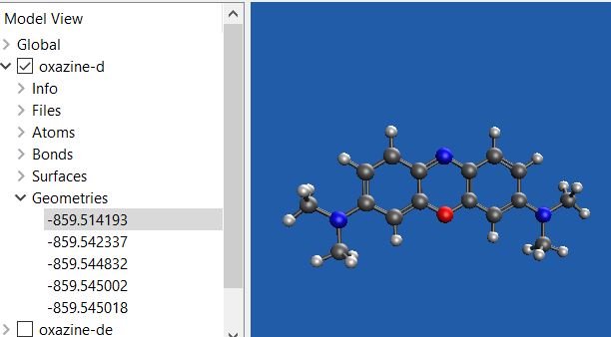
By expanding, or double-clicking the Geometry section in the left window of iQmol, you will be able to visualize iteration steps and view structures for each iteration as the energy is being minimized.
Note: your job task is in the directory you specified when submitting the job; all files there are ASCII (text) files that could be viewed. The file of interest is *.out. When the calculation is finished successfully, it should have the line “Thank you very much for using Q-Chem. Have a nice day” at the end of the file.

- TRANSITION ENERGIES.
Once the structure is minimized, calculate the transition energies and transition dipole moments:
Make the best optimized structure “active” (select it) in the left window; this is the last structure with the lowest total energy in the ‘converging’ list of structures.
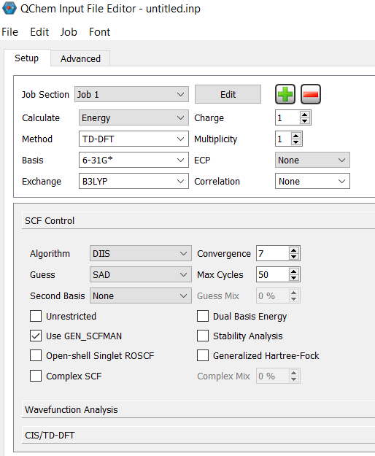
Define Q-Chem job:
Calculate: Energy
Method: TD-DFT
Basis: 6-31G*
Exchange: B3LYP
Make sure the Charge is correct and Multiplicity=1.
In the lower section, there are three tabs:
SCF Control:
Convergence = 7 (higher precision takes too long)
CIS/TD-DFT:
select “Singlets”,
unselect “Triplets”,
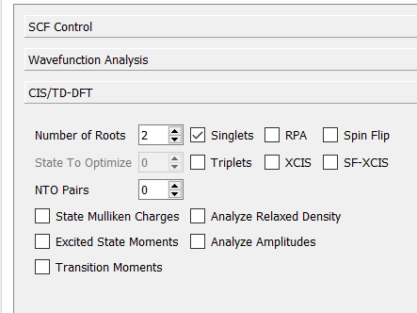
Number of roots = 2
Submit the job. Pick a different directory for this job, as it will overwrite the other job. This will be a much faster calculation.
Copy the results into your PC and open in iQmol.
The results:
Excited States – will show the energies of the 2 lowest transitions along with oscillator strengths.
Canonical orbitals: double click to calculate and display HOMO and LUMO orbitals
Files> *.out have all the information on calculations and also have transition dipole moment vectors listed (search for “Excited”, you will find the direction of the transition dipole moment). Note that the permanent dipole and the transition dipole of a molecule are different animals.

What to submit for grading:
- The pictures of the initial and final optimized structures. In the case of Chl a, especially if viewed from a side, you may see a significant deviation from the initial X-ray structure. Why is that?
- Plot of HOMO and LUMO orbitals. Briefly discuss the differences.
- The HOMOLUMO transition energy and compare that with the experimental value from HW01 or from the literature.
- The magnitude of the transition dipole moment between HOMO and LUMO orbitals, and also its direction with respect to the molecular axes (plot a vector on top of the molecule). Compare this computed TDM with one you found from experimental data in HW01 and, in the case of Chl a, the published value.

